TE-510H COMPUTERIZED EMBROIDERY MANUAL V2.0

CONTENT

PART 1 THE INTRODUCTION OF THE SYSTEM
PART 1 THE INTRODUCTION OF THE SYSTEM 1
  - SUMMARY 1
  - PRECAUTIONS 1
  - WORKING ENVIRONMENT 2
  - SYSTEM POWER SUPPLY AND GROUNDING 2
  - CONTROL PANEL AND KEYS FUNCTION 3
1.5-1 Control Panel 3
1.5-2 Keys Function 4
1.5-3 Function 6
PART 2 EMBROIDERY WORKING PROCESS 7
PART 3 DESIGN INPUT 9
3.1 DESIGN IN THE U DISK INPUT TO MEMORY 9
PART 4 DESIGNS MANAGEMENT 11
  - SELECT DESIGN 11
4.1-1 Photo Embroidery 12
  - CUT DESIGN 13
  - COMBINE DESIGN 14
  - DELETE SINGLE DESIGN 16
  - DELETE ALL DESIGNS 17
  - INPUT DESIGNS TO U DISK 17
PART 5 EMBROIDERY DESIGN 18
  - EMBROIDERY STATUS SWITCH 18
  - PREPARATION STATUS 19
5.2-1 Set Design Parameter 20
5.2-2 Switch Frame 21
  - WORK STATUS 22
5.3-1 Design Origin (Start Point) Set 23
5.3-1-1 Low speed check pattern outline 23
5.3-1-2 Embroidery pattern profiles 23
5.3-2 Offset (Another Start Point) Set 24
5.3-3 Offset point (top of the frame) access operation 24
5.3-4 Return Origin (Start Point) 24
5.3-5 Return Stop point 25
I

TE-510H COMPUTERIZED EMBROIDERY MANUAL V2.0
5.3-6 Set Change Color 25
5.3-6-1 Set Change Color Sequence (sticking cloth offset) 26
5.3-6-2 Replace Stitch Bar 28
5.3-6-3 Set the needle bar display color 29
5.3-7 Change Working Mode 30
5.3-8 Embroidery Mode Switch 30
5.3-9 Positioning Idling 31
5.3-9-1 Add the Specified Stitch/Reduce the Specified Stitch 32
5.3-9-2 Forward a Color / Backword a Color 33
  - EMBROIDERY RUNNING STATUS 33
  - STITCH BAR OPERATION 34
  - SEQUIN HEAD SWITCH CONTROL AND INDICATOR 34

PART 6 LETTERS TO GENERATE EMBROIDERY 35

PART 7 MANUALLY CHANGE COLOR 37

PART 8 MANUALLY TRIMMING 38

PART 9 FRAME ORIGIN 39
  - MANUALLY SET FRAME ORIGIN 39
  - AUTOMATICALLY FIND ABSOLUTE ORIGIN 40

PART 10 FRAME SET 41

PART 11 STATISTIC 43

PART 12 MAIN AXIS JOG OPERATION 44

PART 13 LANGUAGES 45

PART 14 EMBROIDERY PARAMETERS 46

PART 15 SET MACHINE PARAMETERS 47

PART 16 USERS MANAGEMENT 48
16.1 TIME SETTING 48
16.1 REMOVE UNLOCK 49

II

TE-510H COMPUTERIZED EMBROIDERY MANUAL V2.0

PART 17 SYSTEM TEST 51
  - INPUT TEST 51
  - OUTPUT TEST 51
  - AXIS TEST 52
  - MACHINE HEAD TEST (USED ONLY IN ORGANIC HEAD PANELS) 53

PART 18 SYSTEM INFORMATION 53
  - SYSTEM NO. AND VERSION INFO 53
  - SYSTEM UPDATE 54
  - INTERFACE UPGRADE 54

PART 19 NETWORK SETTINGS 55

PART 20 APPENDIX 56
20. 1 PARAMETER TABLE 56
20. 2 SYSTEM FAULT AND SOLUTION 60

III

TE-510H COMPUTERIZED EMBROIDERY MANUAL V2.0

PART 1 THE INTRODUCTION OF THE SYSTEM

Summary

Thank you very much for using our computerized embroidery machine control system!
This system can be applied to variety of embroidery machines to meet different requirements of yours. it will provide you with satisfactory effect for thin and thick materials as well as 3D embroidery!
The advanced RAM+DSP control technology makes the system work faster. the friendly man-machine interface of the system effectively improves the productivity; This control system adopts smooth curve regulation. which makes the machine running more stable. reduces the noise and extends the service life of the machine!
Please read carefully this Manual before using so as to ensure correct operation of the system.
Please keep this Manual properly for future reference.
Due to the difference of configuration. some machines may not be equipped with some functions listed herein. please follow corresponding functions.

Precautions

Non-professional personnel can never be allowed to carry out maintenance and debugging of the electric system. or the safety performance of the equipment will be reduced. the malfunction will be more serious. and even personnel and property damage will be caused.
Some parts in the case are with high tension. in order to avoid any accidental damage. when the system is powered on. do not open the cover of the case.
Please replace the protective tube strictly in accordance with the identification of the product to ensure personal and property safety.
The power switch of this product is provided with over-current protection. in case the over-current protection switch acts. it will not be closed again until 3 minutes later.

1

TE-510H COMPUTERIZED EMBROIDERY MANUAL V2.0

The floppy drive is a precision device. please always remember to insert the disc in the right direction. to avoid damage of the disc or the drive. do not eject or insert the disc during reading or write of the disc (when the floppy disc indicator is on). As the disc is made of magnetic material. it should be kept away form any magnetic field to avoid damage of the disc or loss of the data.
Do not pile up sundries around the control box. and during the operation. the surface of the control box and the filter mesh should be cleaned regularly to keep fine ventilation of the system and facilitate the cooling.
Do not modify the product without authorization of the company; the company should bear no responsibility for any consequence resulted therefrom!

Warning
If it’s necessary to open the cover of the case. do not touch any part in the electric cabinet unless you are under direction of professional personnel and the power has been turned off for over 5 minutes!

Prohibitions
Do not touch any moving part or open the control device during operation of the machine. otherwise. it may cause personal damage or abnormal operation of the machine!
It is prohibited to operate any electrical equipment in damp location or environments with dust. corrosive. flammable or explosive gases. otherwise. it may cause electric shock or fire!

Working Environment
Ventilating and sanitary environment with little dust; Working Temperature: 5-40°;
Working RH: 30%-90%. no frost.

System Power Supply and Grounding
This electric control system can use the following power supplies:

2

TE-510H COMPUTERIZED EMBROIDERY MANUAL V2.0

Single phase AC100-220V/50-60HZ
According to different configuration. The consumption power is between 0.1-0.4KW

To avoid electric shock or fire due to leakage of electricity. over-voltage or insulation etc.. please ground the electric control system reliably.
Grounding resistance less than100 ohms. wire length within 20M. the area of wire greater than 1.0 MM2

  - Control Panel and Keys Function

1.5-1 Control Panel

Control panel is that interface display and operation control in the system. show as:

3

TE-510H COMPUTERIZED EMBROIDERY MANUAL V2.0

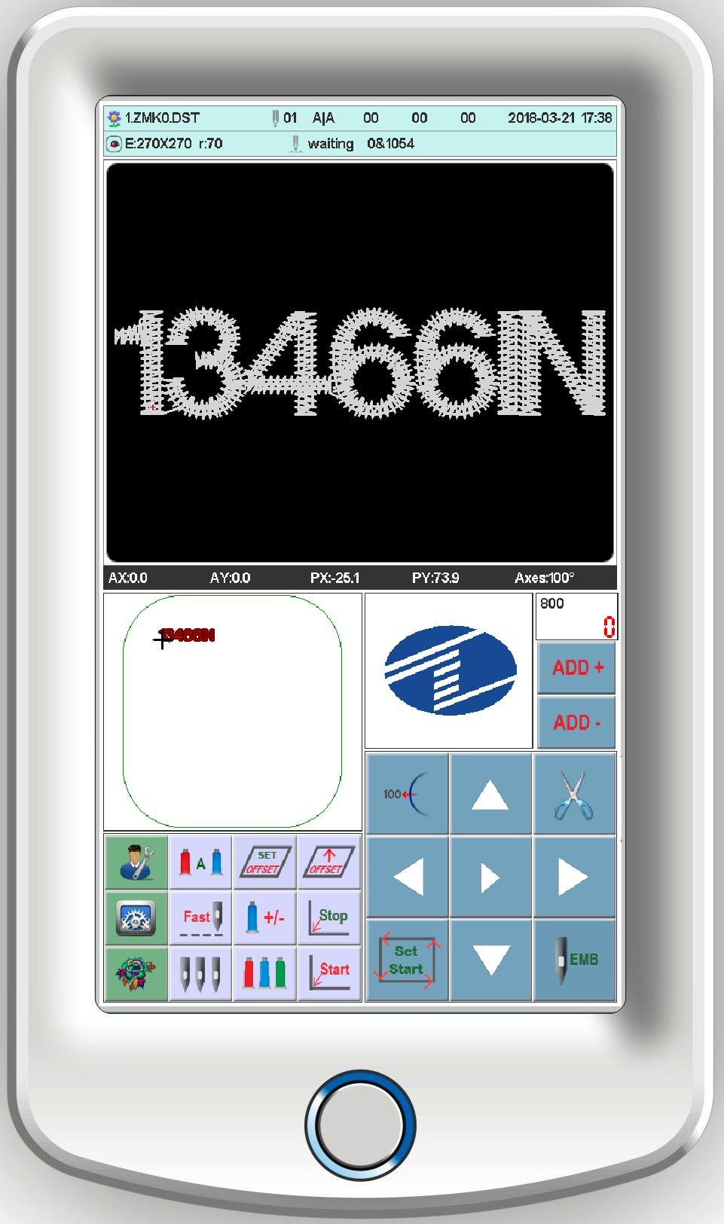

1.5-2 Keys Function

manually trimming key: when it's in the working status and preparation status. do the manually trimming operation
jog main axis key: click the key to jog main axis to 100 degree.
select key: to choose frame movement and control main axis speed.

4

TE-510H COMPUTERIZED EMBROIDERY MANUAL V2.0

directional keys: when in the embroidery and
preparation status. to move frame.

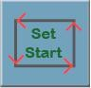adjust main axis speed

origin point Return to origin offset point
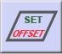 Set offset
work mode switch key(automatically change color automatically start embroidery mode)
manually change color set change color
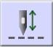 embroidery mode switch (normal embroidery) remove embroidery
idling embroidery return stop point
AX/AY：display relative design origin coordinate PX/PY：display relative frame origin coordinate

5

TE-510H COMPUTERIZED EMBROIDERY MANUAL V2.0

1.5-3 Function

This system has friendly man-machine interface and the operations are simple with powerful functions. which can greatly facilitate the operations of the user and improve the performance and efficiency.
Multiple language supported. select according to your requirement
With large memory capacity. the system can store 20000000 stitches and 200 designs Multiple means for designs. greatly facilitate to select and use for customer. U disk. USB
(required supporting PC software). network (required supporting PC software)
Support multiple design file formate. can recognize Tajima DST and Barudan DSB. etc..
Strong parameter adjustment functions enable you to adjust various parameters according to different requirements to achieve the system control performance you need.
When power off. the function of “Auto Restoring embroidery after power off” enables
the machine to continue embroidering from the stitches just before the power off. you need not worry about displacement of designs and realign the positions.
The “Self-checking of devices” function enables checking of the status and parameters
of external devices and facilitates adjustment and maintenance.
The“Main axis stop position adjustment” function enables the user to adjust parameters of the system according to the characteristics of the embroidery machine to achieve correct stop position.
The“Auto memorizing of embroidery design parameters” function can automatically store the preset embroidering parameters or related data of embroidered designs. including color changing. the origin. the offset point. embroidering parameters and repetition etc.. so as to facilitate the embroidery of the next time.
The “Patching offset” function enables user to set any change color stitch bar to path the frame. facilitate the patching embroidery.
The precise pattern beeline embroidering functions can meet you requirements for locating design embroidery.

6

TE-510H COMPUTERIZED EMBROIDERY MANUAL V2.0

PART 2 EMBROIDERY WORKING PROCESS

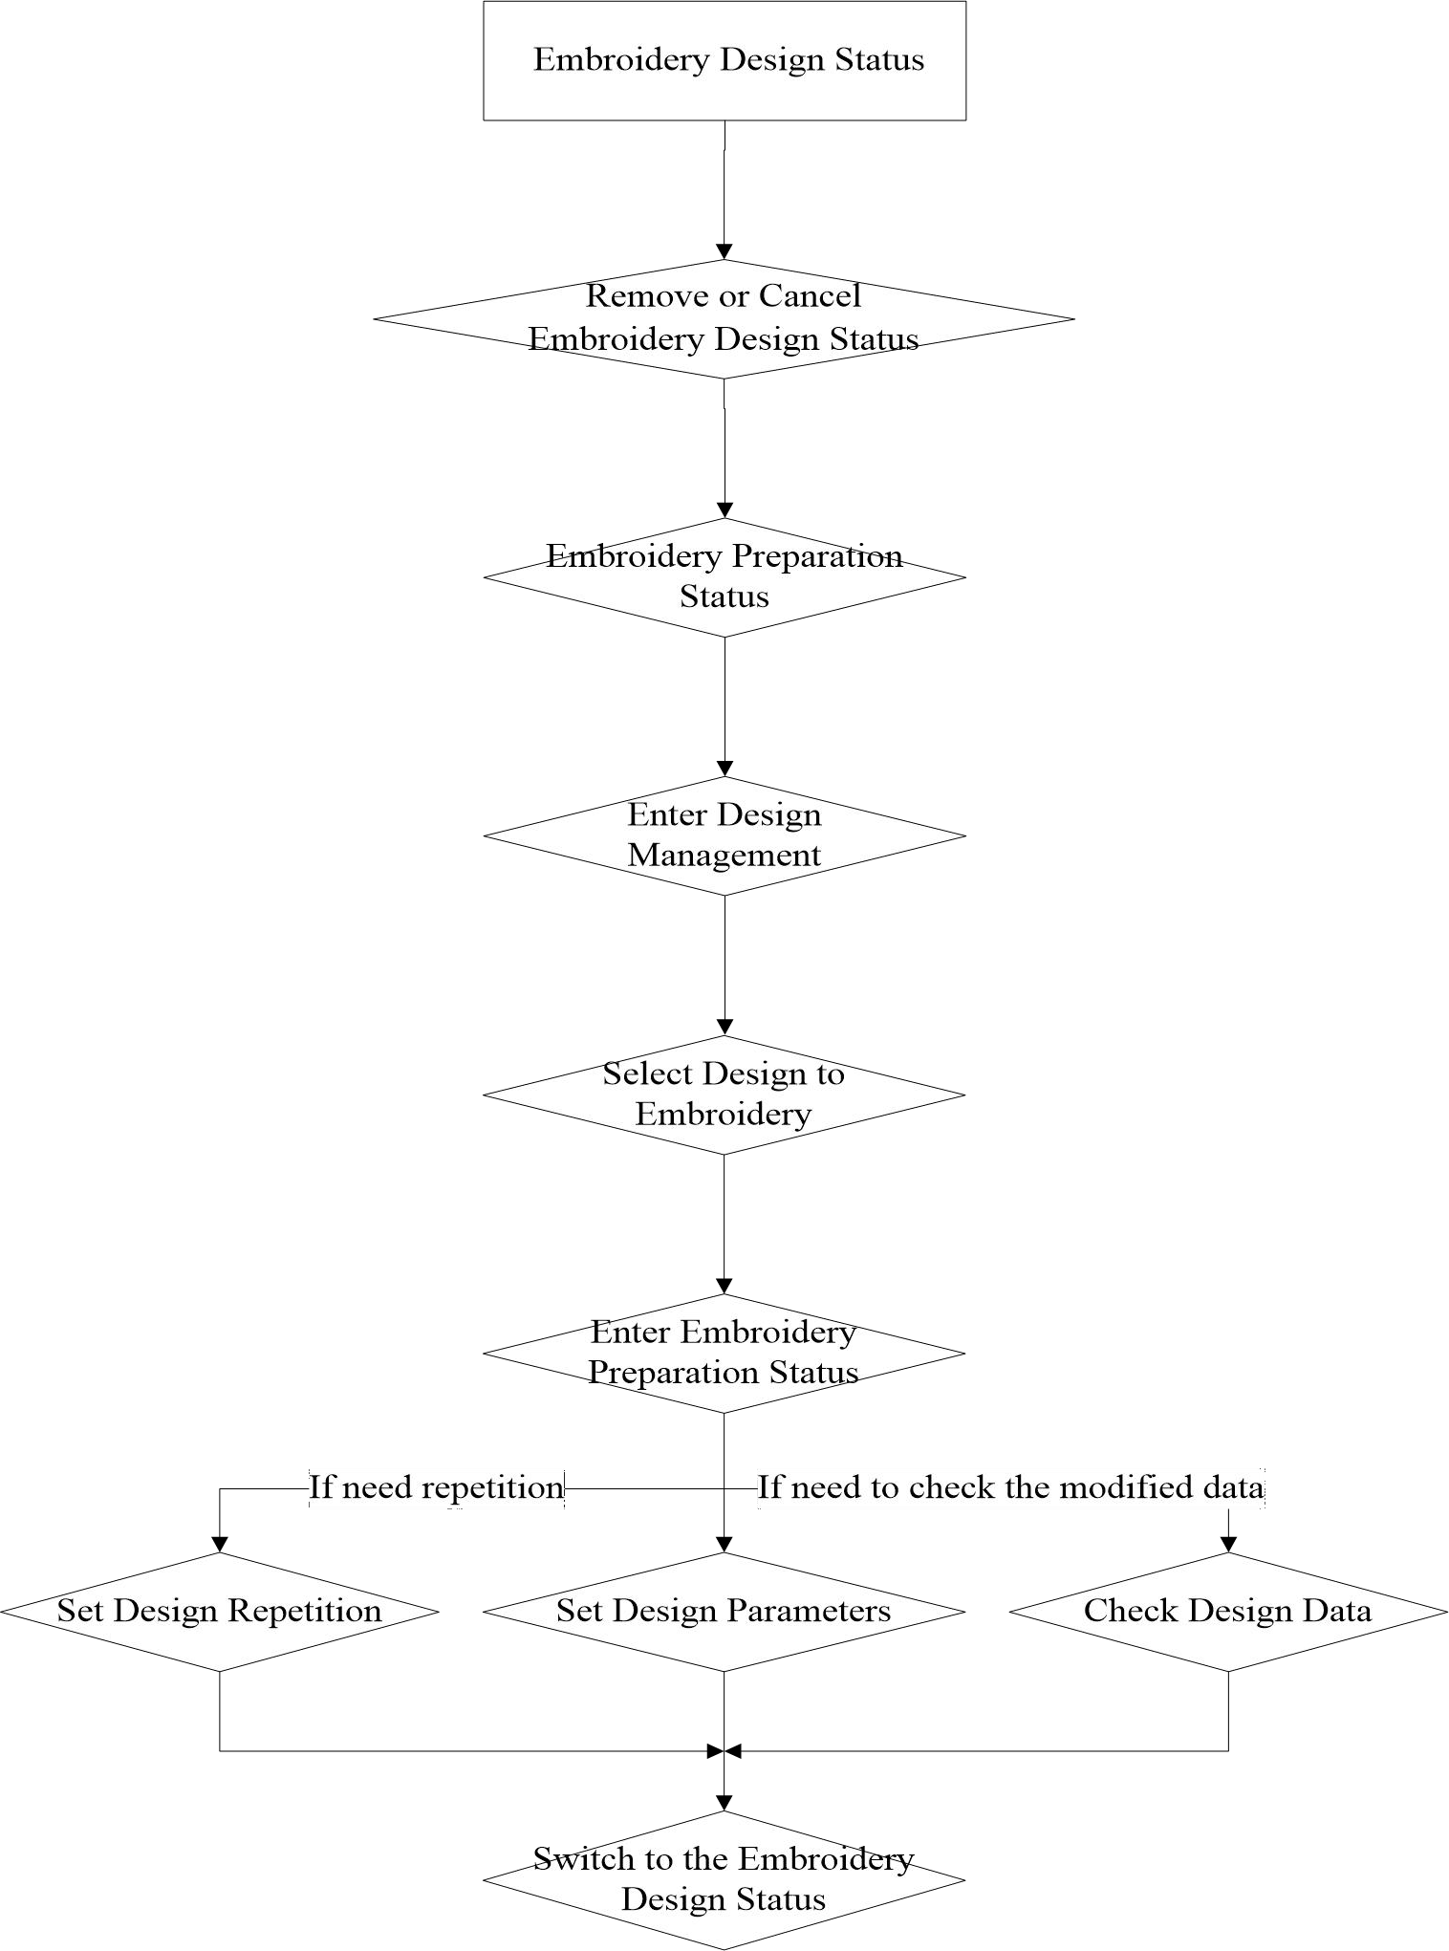

7

TE-510H COMPUTERIZED EMBROIDERY MANUAL V2.0

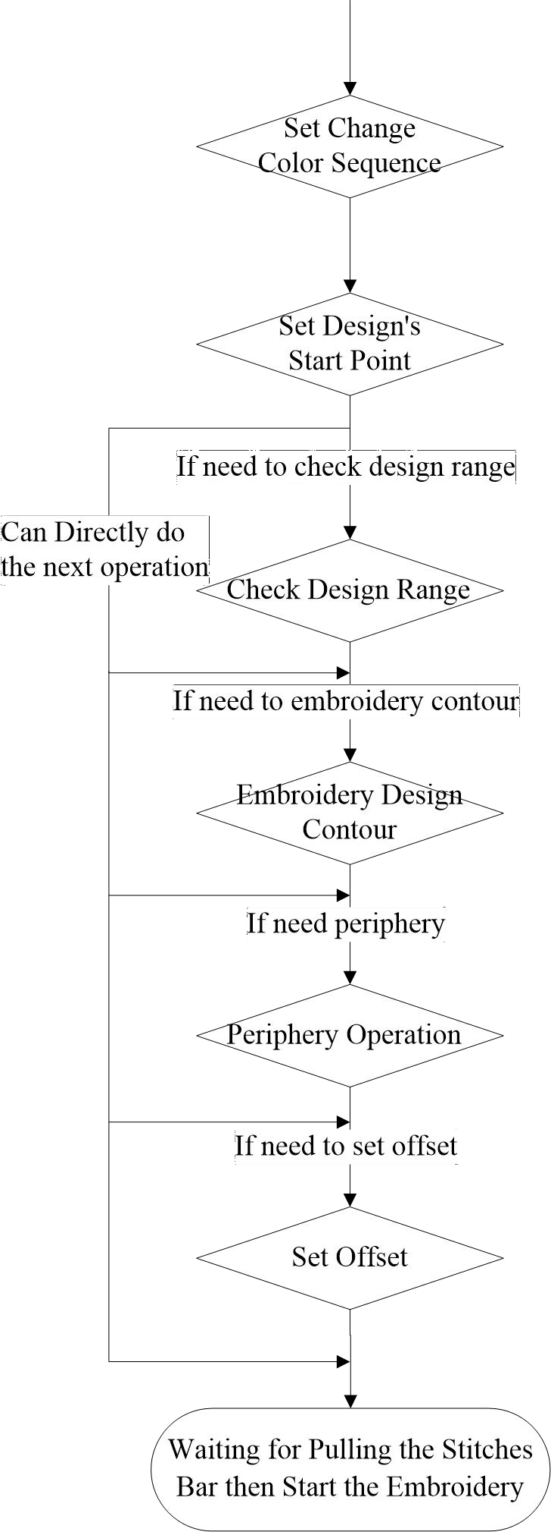

8

TE-510H COMPUTERIZED EMBROIDERY MANUAL V2.0

PART 3 DESIGN INPUT

Design input is that designs in the U disk input to memory. which can be operated in the embroidery preparation status and embroidery design status.
Design input. files in the external storage medium input to system memory. facilitate to select embroidery. If no designs in memory. it'll enter into the interface when start system.
The system. support reading Tajima DST and Barudan DSB 2 formates. Before reading design. insert U disk to USB port. then operate panel.

3.1 Design in the U Disk Input to Memory

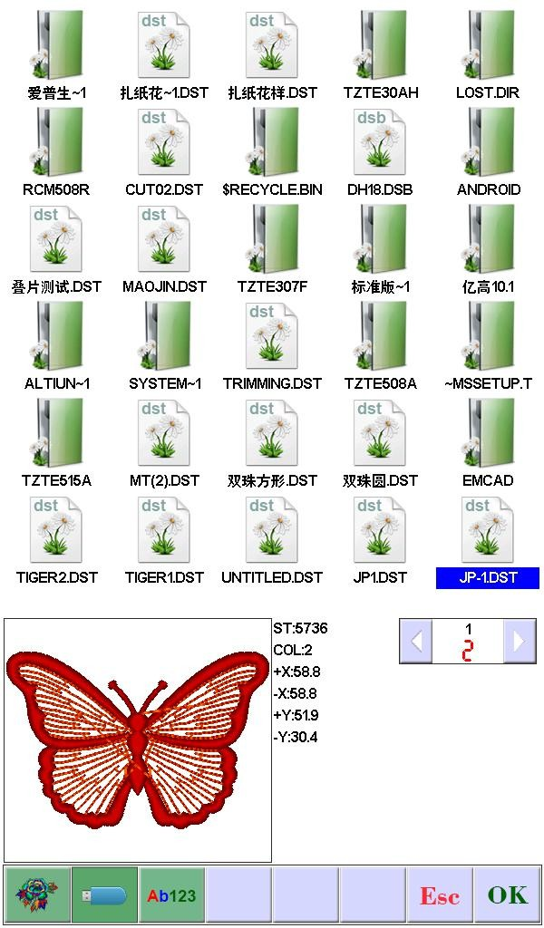
In the main interface, press key to enter the layout management interface. click . show as:

9

TE-510H COMPUTERIZED EMBROIDERY MANUAL V2.0

Click the required designs. click . automatically display "input process" situation: memory No. And input process. after finishing. automatically return back U disk interface. do the next operation.
Click to return the last interface.

10

TE-510H COMPUTERIZED EMBROIDERY MANUAL V2.0

PART 4 DESIGNS MANAGEMENT

Designs management. contain that select design. output design. combine design. cut design. delete design. delete all designs( can not delete in the embroidery status).
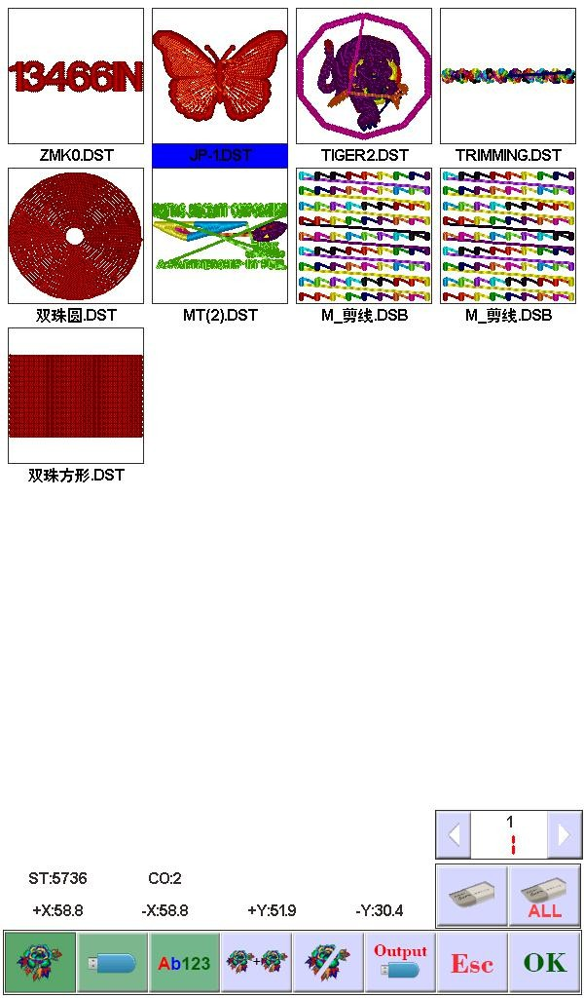
In the main interface, press key to enter the layout management interface.

Select Design

In the "Design Management" interface. The default enters to select the flower version Click the required design. whose relative information will be displayed in the screen. The
selected design No. And name background change as blue. Click to enter "embroidery preparation status".
When memory design has many pages. click the directional keys to turn the page.

11

TE-510H COMPUTERIZED EMBROIDERY MANUAL V2.0

Longly click the selected design 3 seconds. can show the design in full-screen. touch screen a time to return the selected design interface.
In the embroidery preparation status. can set the required embroidery parameters. design rotate direction. zoom. rotate angle. repetition. satin stitch compensation.

4.1-1 Photo Embroidery

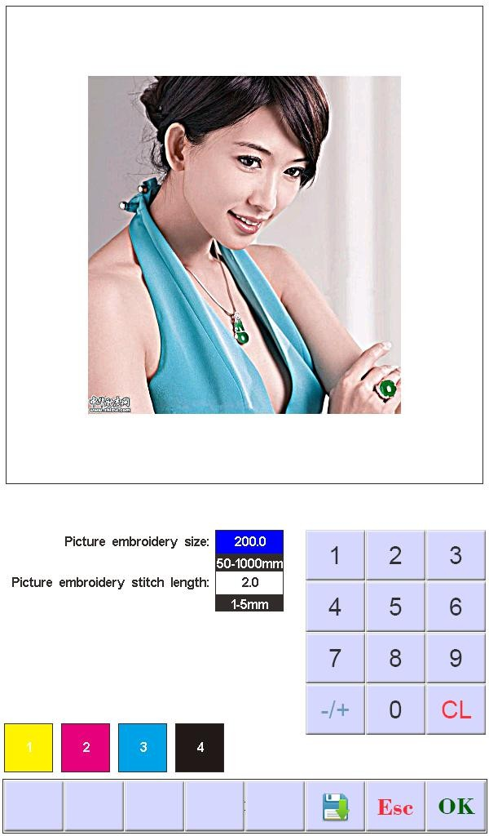
In Flower version Management interface,Select the pictures（BMP,JPEG Format） that need embroidery, pressKey into the photo Setup screen,As shown in figure:

According to the need to set the picture width (height by proportional automatic adjustment), set embroidery needle length, needle step the smaller embroidery reduction degree, the more flower version of the needle will be more, customers can adjust according to their needs, after the completion of The key begins to generate the embroidery file, as

12

TE-510H COMPUTERIZED EMBROIDERY MANUAL V2.0

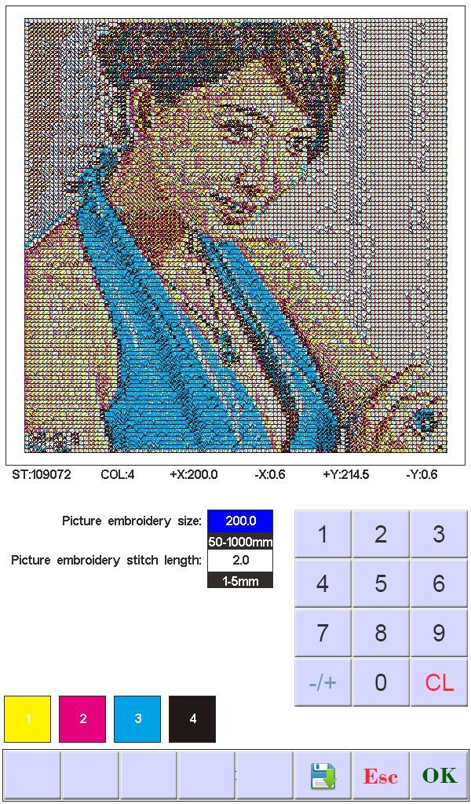
shown in figure:
In this interface, the parameters can be changed again according to the requirements to continue to generate.
The color of the lower-left corner is the color order of the flower version: Yellow, red, blue and black. Customers can shade colors based on the base color.
Press The key enters the preparation embroidery interface, carries on the embroidery related setting.

Cut Design

In the "Design Management" interface. click .
Click the required design. Click the required design. whose relative information will be

13

TE-510H COMPUTERIZED EMBROIDERY MANUAL V2.0

displayed in the screen. The selected design No. and name background change as blue. Click

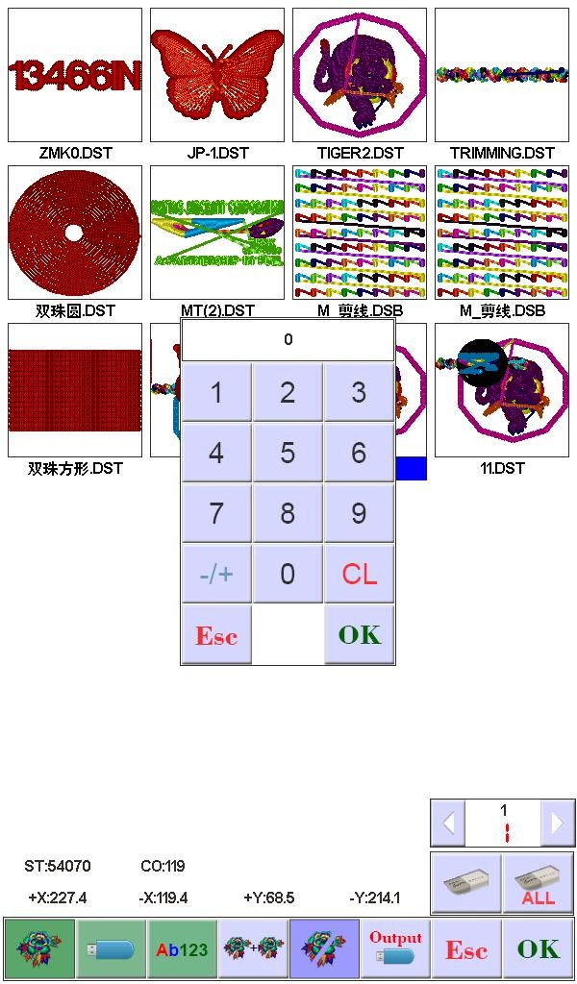
. show a box. input the cut stitches. show as:
Click to confirm. then it'll prompt that the design's storage number and cut progress after cutting. After finishing. it'll automatically return "Cut Design" interface.

Combine Design

In the "Design Management" interface. click 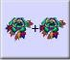 Key to enter the combination of
engraving operation.Click the required design. a design can be selected more times. the maximum is 4 designs to combine a file. the selected design number and name will display in the screen. show as:

14

TE-510H COMPUTERIZED EMBROIDERY MANUAL V2.0

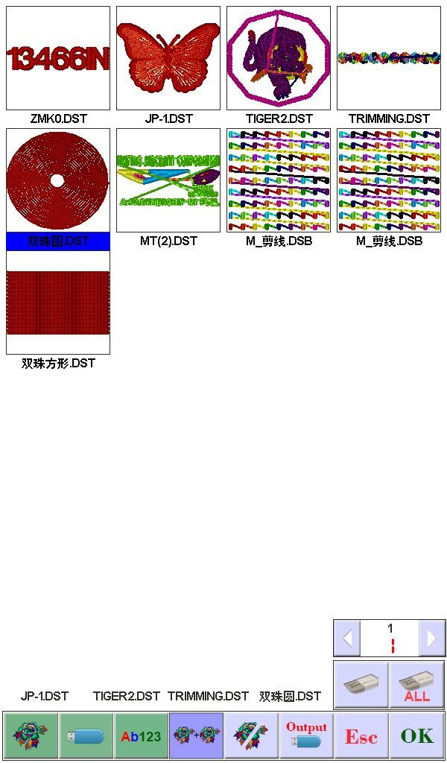

Click . show as:

15

TE-510H COMPUTERIZED EMBROIDERY MANUAL V2.0

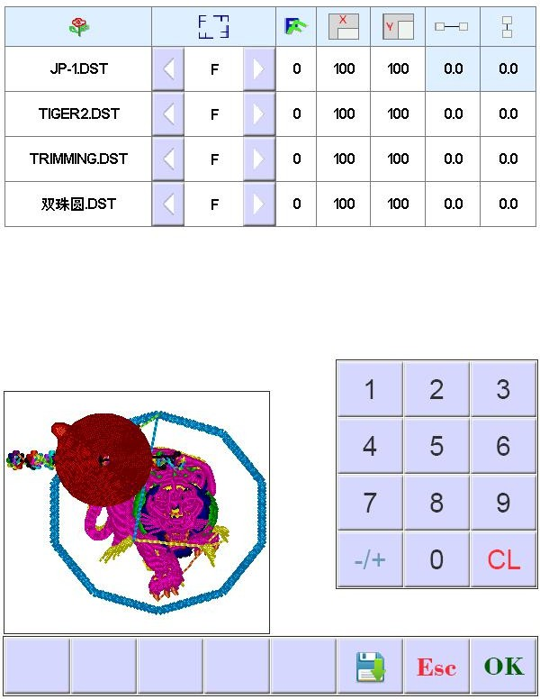
According to combination requirements. set the need value. then choose combination
mode. click to confirm. Storage number and name will be automatically generated.
Press the key to save the combination of the flower version, the system automatically given the storage number and name.

Delete Single Design

In the "Design Management" interface. click 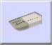 . select design. click to confirm.

16

TE-510H COMPUTERIZED EMBROIDERY MANUAL V2.0

Delete All Designs

In the "Design Management" interface. click 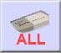. click . if you confirm to delete. click . if don't delete. click to quit.

Input Designs to U disk

In the "Design Management" interface. Click 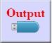. select designs. click to U disk.

17

TE-510H COMPUTERIZED EMBROIDERY MANUAL V2.0

PART 5 EMBROIDERY DESIGN

Embroidery Status Switch

Embroidery status has 3 kinds: preparation status. working status. and running status. You can switch them by the keys on the interface. Pull stitch bar to enter "running status". show as:
Preparation Status

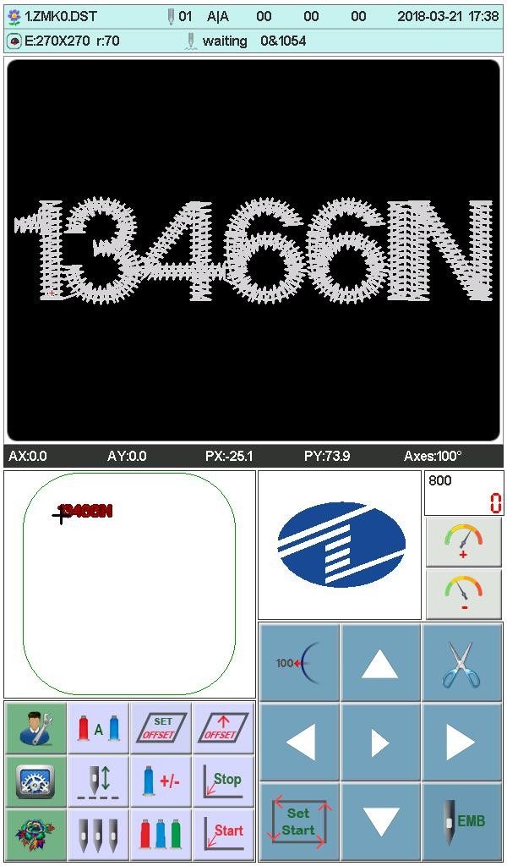In the preparation status. click . show a dialogue box "whether to enter working
status?" click to confirm. show as:
If no designs in memory. it'll prompt that "don't choose design". and can not enter working status.

18

TE-510H COMPUTERIZED EMBROIDERY MANUAL V2.0

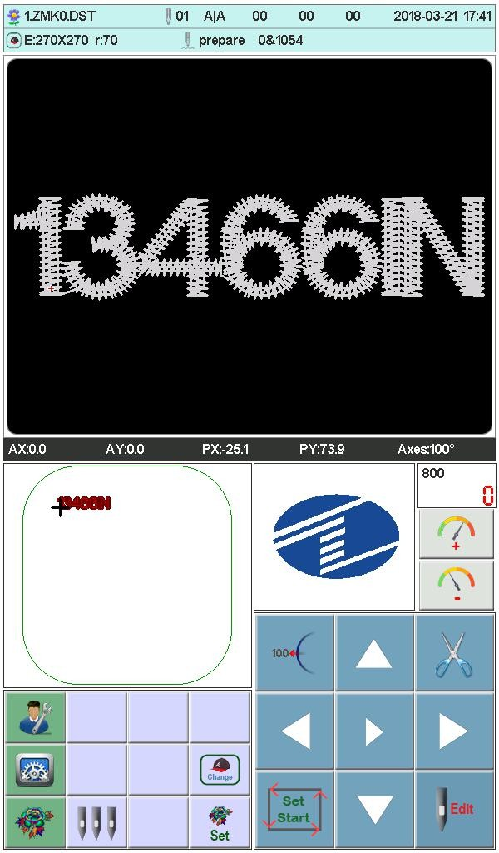
Working Status

In the working status. click . show a dialogue box "whether to remove working status ? " click to enter preparation status.

Preparation Status

In preparation status. can do the operations: main axis jog. trimming. switch frame. manually change color. set design parameter and select design etc.

19

TE-510H COMPUTERIZED EMBROIDERY MANUAL V2.0

5.2-1 Set Design Parameter

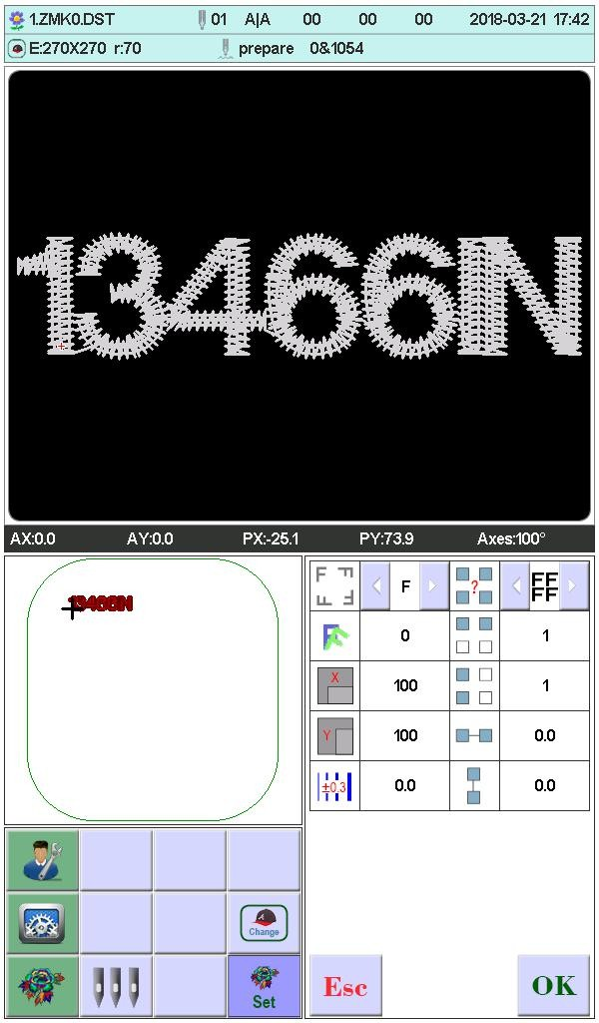
In preparation status. click . show as:
Modify the numerical value according to your requirements. then click to save. or click to return the preparation status interface.
Parameter Range:

Rotation Direction: default has 8: 0°、90°、180°、270°、0°mirror、90° mirror、180°mirror、270°mirror
Rotate Angle:0-89°（calculate after the rotation direction） X/Y direction magnification: 50%-200%

20

TE-510H COMPUTERIZED EMBROIDERY MANUAL V2.0

Repetition: ordinary. X symmetry. Y symmetry. XY symmetry

X/Y repetition: 1-99 ( ordinary X/Y99. X symmetry X2/99. Y symmetry X99/Y2. XY symmetry X2/Y2)

X/Y distance: 0-±999.9mm

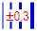
The unit is mm. and numeric value input 0.1m. for example. if need to input 100mm. please input 10000.
X/Y compensation (satin stitch): 0-±0.3
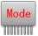 Head mode selection (limited function): After the combination function of the
nose, the use of ordinary mode or combination mode embroidery, ordinary embroidery for each nose work at the same time, combined embroidery for a single double head with embroidery a flower version.
Tape Embroidery interval (limited function): the spacing between
the starting points of each pattern when the Ribbon embroidery function is turned on, using the scrolling display function. 0-999.9mm, when set 0 points, normal embroidery. When you set up 1-999.9, the automatic swap tape feature is turned on. When setting the tape display interval, the interval size can only be less than the Y of the embroidery box to maximize the embroidery size (Y embroidery box size), otherwise it will not work properly.

5.2-2 Switch Frame

In the preparation status interface. click. show as:

21

TE-510H COMPUTERIZED EMBROIDERY MANUAL V2.0

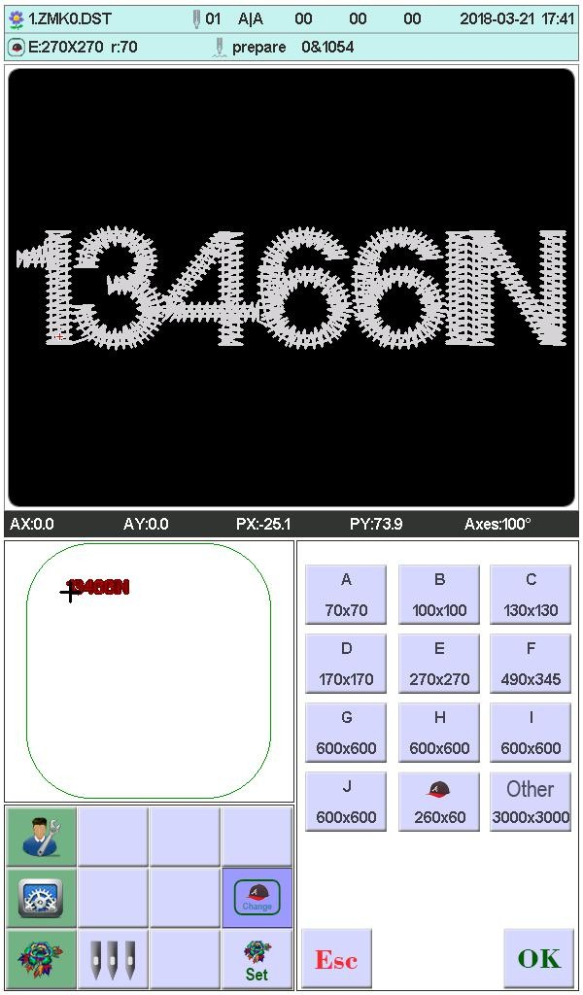
Select the current required frame type from A-J and cap frame. the frame will automatically find absolute origin. and stop at the middle of the frame. please note the frame movement. Embroidery range and the middle point of Cap frame and A-J frame. see the frame set. Other frame don't find absolute origin. embroidery range set as software limit (detail operation see software limit set)
After choosing frame. automatically return to the preparation status interface. if not choose. the system will use the last used type.
When choose cap frame. the current selected design will automatically rotate 180°. The
others not change.

Work Status

In the working status. can set design origin( start point). offset (another start point). return origin. return offset. return stop point. change color sequence. jog main axis. manually trimming. manually change color. change working mode. embroidery mode switch. position

22

TE-510H COMPUTERIZED EMBROIDERY MANUAL V2.0

idling. embroidery design contour. embroidery straight angled line. embroidery + line. embroidery straight line. moving frame generated design. view embroidery range. power off return embroidery working point. check design and frame proportion etc.

5.3-1 Design Origin (Start Point) Set

In the working status. move frame to design's origin (start point). Press key to set the flower version yuandian go home and check the box along the pattern maximum range.
AX/AY coordinate clear.
If the current design had been set origin point. it'll prompt that "origin point had been set.
if need to reset again?" click to reset the current position as origin point. the old offset also will be cleared. Click . not set. continue to use the last origin.

5.3-1-1 Low speed check pattern outline

After setting a starting point, press the button to start generating the outline of
flower version, after the completion of the frame Auto slow empty embroider contour, contour after completed the frame automatically returns to the starting point of flower version. If you spend beyond the frame setting range version, the system will pop flower embroidery version beyond the scope of the error message.

5.3-1-2 Embroidery pattern profiles

After setting the start point, press the button to start generating the outline of
flower version, after the completion of the embroidery frame embroidery automatic contour, after the completion of the outline of the embroidery frame will automatically return to the

23

TE-510H COMPUTERIZED EMBROIDERY MANUAL V2.0

starting point flower version. If you spend beyond the frame setting range version, the system will pop flower embroidery version beyond the scope of the error message.

5.3-2 Offset (Another Start Point) Set

Set the offset point is mainly to facilitate the retractable embroidery materials and placed with the patch, set the offset point must be set before the origin (from the embroidery point).
When the offset point is not set, the default default frame is the offset point.
Press the button, the interface pops up the prompt "move the box to the offset point, press the OK key.", Manually move the box to the need to frame the location, press the

button to complete the set.
After setting, each time after the start of the embroidery frame automatically return to the origin of embroidery began embroidery. After the embroidery is completed, the frame is automatically stopped to the offset point.

5.3-3 Offset point (top of the frame) access operation

Press key to the frame between the current position to set the frame size of
most apex mobile, each press of the button, in the parking position to move alternately between the vertices.
When automatic offset whether parameter setting: "Yes", after the completion of the embroidery frame embroidered flower version will automatically move to set the frame size of the vertex stop, start again automatically after return to the last starting position start embroidery.

5.3-4 Return Origin (Start Point)

In the embroidery midway. if need to return origin to start again. can do the operation.

24

TE-510H COMPUTERIZED EMBROIDERY MANUAL V2.0

Press key. the system will prompt that "if terminate embroidery. return origin?". click . frame will move to design origin and stop. AX/AY coordinate clear.

5.3-5 Return Stop point

Stop in the embroidery midway. after manually moving frame. need to return stop point. can do the operation.

Press key . the frame will auto-move to the point that manually move. and
stop.

5.3-6 Set Change Color

Set change color contains change color sequence. replace stitch bar. In the working status. click . show as:

25

TE-510H COMPUTERIZED EMBROIDERY MANUAL V2.0

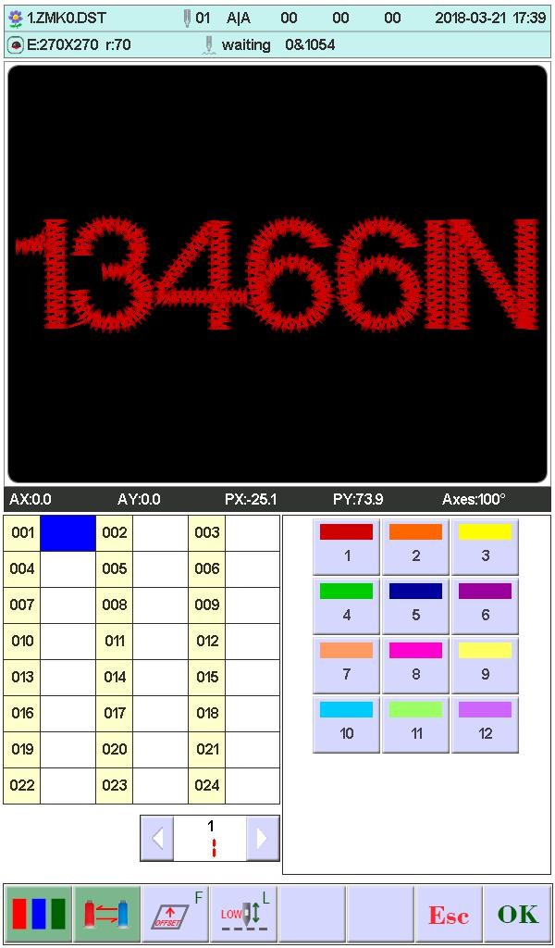

5.3-6-1 Set Change Color Sequence (sticking cloth offset)

In the interface. 001 ～ 200 means the change color times (the system only support 200 times). the cursor in the interface will start with the last position which has stitch bar value. input the current color sequence corresponding stitch bar No.. then the cursor will move the next sequence.
In the setting midway. if the front stitch bar No. error. select it and reset.

Offset out of the frame:
When a color sequence need offset frame out (stitching cloth path embroidery).
before inputting stitch bar No.. please click 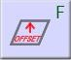 a time. the background of the current stitch bar will change as red. If you need to cancel it. click a time.

Low speed embroidery:

26

TE-510H COMPUTERIZED EMBROIDERY MANUAL V2.0

If the cursor is in a color order, you need to use low-speed embroidery automatically,
press the 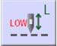 key immediately before entering the needle bar, and increase the "L" after the current needle bar number. If you want to cancel low-speed embroidery, press
again key.

Simple towel embroidery:
If the cursor is in a color order, you need to make simple towel embroidery, press
the 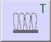 button without input needle bar, and increase the "T" after the current needle bar number. If you want to cancel the towel embroidery settings, press again key.
The height of the towel can be adjusted as needed

Rotary Belt needle Bar set (function Limited):
It is used only in the machine with the function of tape embroidery. The default is mounted on the right side, using the first needle disconnection detection.
The Belt embroidery function has10Working mode selection, 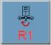 Left winding Embroidery, 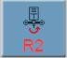 Right winding embroidery, 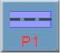 Ordinary belt embroidery, 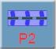Fold Belt Embroidery, 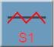Left rope embroidery, 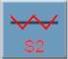Right rope embroidery, 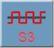 Rope Embroidery3. 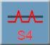 Rope Embroidery4. Rope Embroidery5. 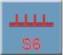Rope Embroidery6.
When you need to set the tape embroidery mode, press 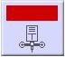 The key enters the selection interface, as shown in the figure:

27

TE-510H COMPUTERIZED EMBROIDERY MANUAL V2.0

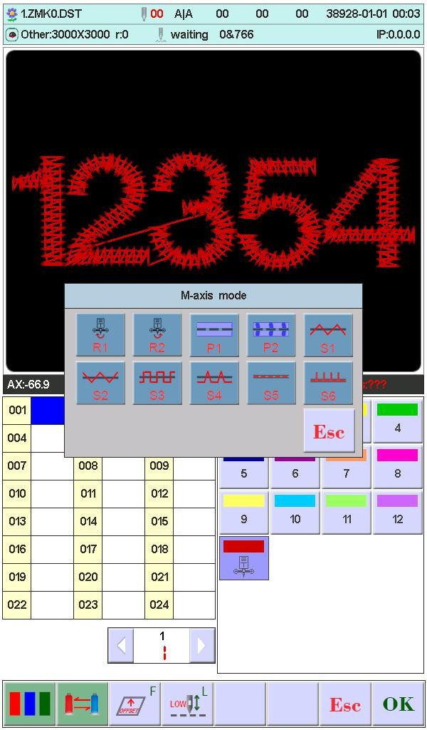
Depending on the pattern you are currently looking for, the left color order displays the corresponding pattern number.

Presser foot height adjustment (electric presser foot. This setting is set to open when the independent presser function is turned on):
In the use of electric lift foot function, each color of the presser foot height can be adjusted according to need. Do not set the default height when using embroidery parameters.
Complete setting. click to save. in the function. the system will save the the cursor position prior data

5.3-6-2 Replace Stitch Bar

The function is used for disposable modify a certain stitch of all color sequence.
In the change color setting interface. click 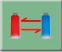 . Click on the selected needle bar

28

TE-510H COMPUTERIZED EMBROIDERY MANUAL V2.0

needs to be replaced, all the same needle position are selected, press the key you want to use (replace) the completion of the replacement value of the needle bar needle bar operation.

5.3-6-3 Set the needle bar display color

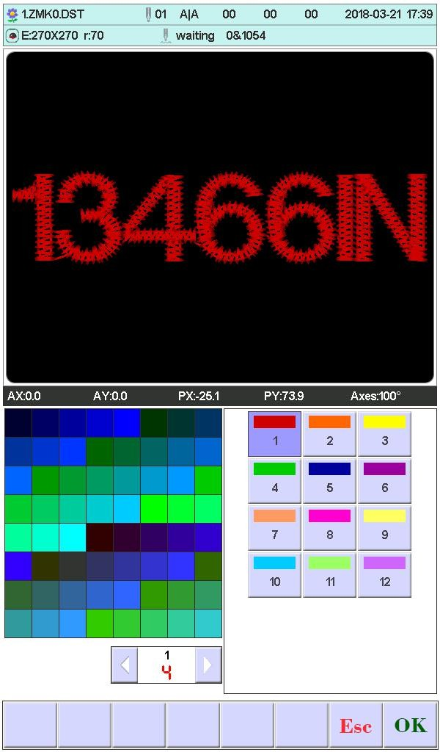
After setting the color change interface, press the 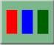 key to enter the needle bar display color setting, show as:
First press the key to select the needle bar button to be set, and then click the left color block to select the desired color. After selecting the needle bar to be modified, press the
button to save the selected color. The color of the real-time embroidery preview will be displayedaccording to the set color.

29

TE-510H COMPUTERIZED EMBROIDERY MANUAL V2.0

5.3-7 Change Working Mode

In the working status interface. click to change working mode. click a time and change a mode(cycle change). click keys follow change. the following is automatically change color automatically start mode. manually change color manually start mode.
In the manually change color manually start mode. the set color sequence invalid. Shutdown and p ower on. it is still the modified mode.

5.3-8 Embroidery Mode Switch

Switch embroidery mode. mainly for realization the compensation operation. Users can move the stitch tracking to the specified position by idling embroidery.
In the working status interface. click to change embroidery mode. click a time and change a mode(cycle change). click keys follow change. the following is normal embroidery. low speed idling embroidery. high speed idling embroidery.
low speed idling embroidery:
In the stop state, press the key (low-speed idle), the spindle will not move, the embroidery frame advances along the embroidery stitches, and the low-speed needle feed
stops when the key is released.

30

TE-510H COMPUTERIZED EMBROIDERY MANUAL V2.0

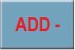
In the stop state, press the key (low-speed evacuation), the spindle will not move, the embroidery frame will go back along the embroidery stitches, and after releasing
the key, the low-speed exit will stop.Stop status.
high speed idling embroidery:
In the stop state, press the key (high-speed air-in), the spindle and the embroidery frame do not move, and the number of embroidery progress needles is increased.
When the key is released, the embroidery frame moves directly to the position of the forward stitch point.
In the stop state, press the key (high-speed evacuation), the spindle and the
embroidery frame do not move, and the number of embroidery progress stitches decreases. When the key is released, the embroidery frame moves directly to the position of the back stitch point.

5.3-9 Positioning Idling

Positioning idling contains add the specified stitch. reduce the specified stitch. forward a color. backward a color.
In the working status interface. click . show as:

31

TE-510H COMPUTERIZED EMBROIDERY MANUAL V2.0

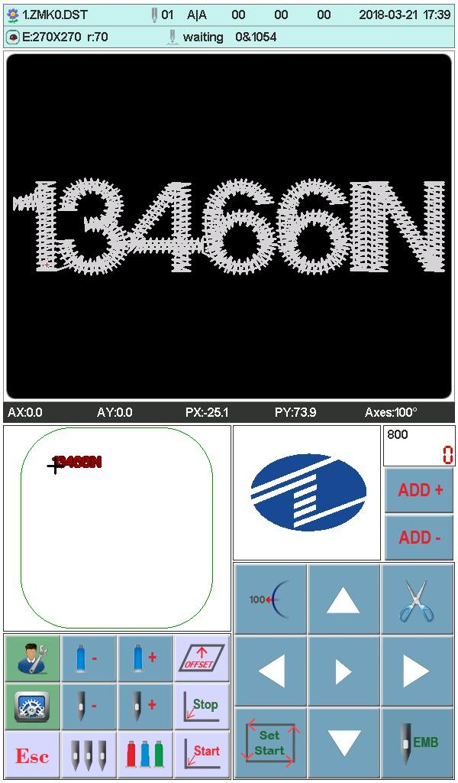

Complete the positioning idling. click to return working status.

5.3-9-1 Add the Specified Stitch/Reduce the Specified Stitch

In the positioning idling interface. click or to choose them. show as:

32

TE-510H COMPUTERIZED EMBROIDERY MANUAL V2.0

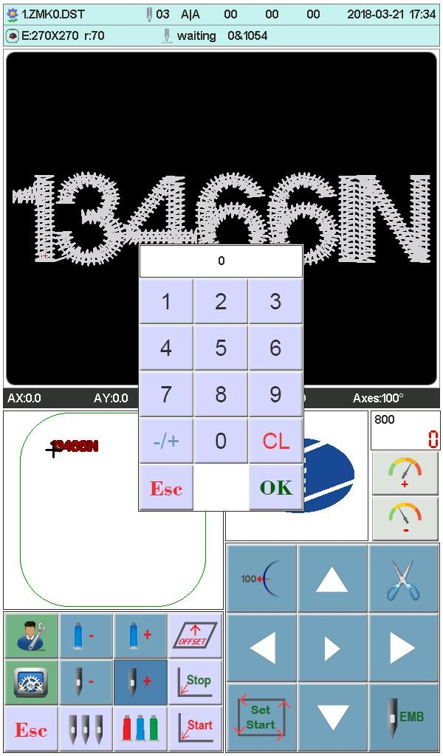

Click numeric keys to input the required stitches. click . frame will directly move to the specified stitch position.

5.3-9-2 Forward a Color / Backword a Color

In the positioning idling interface. click or to choose them. frame will directly move to the specified stitch position.

Embroidery Running Status

In the embroidery running status. only do the main axis lift speed operation.
Click to slow down or speed up main axis rotation speed. Click

33

TE-510H COMPUTERIZED EMBROIDERY MANUAL V2.0

to choose the lifting speed.

Stitch Bar Operation

After completed the relative embroidery parameters. you can click the key to embroidery.
Stop in the embroidery design status: Press the button for more than 3 seconds, the spindle will be embroidered at the lowest speed. click key a time to embroidery.
In the embroidery running status: click the key to stop.

Sequin Head Switch Control and Indicator

Toggle the switch from up to middle. the indicator is green. the landing gear put down (machine lock open). toggle the switch down. slice motor work a time; toggle the switch down more than 2 seconds. the indicator will be orange. release the switch. the landing gear will rise (air pressure)
Switch in the middle. don't enter the sequin embroidery. the indicator is orange. landing gear up. wait send slice. When enter sequin embroidery. landing gear down. indicator change as green.
Sequin head switch up. the indicator off. and close landing gear(when has air pressure. landing gear will automatically rise).

34

TE-510H COMPUTERIZED EMBROIDERY MANUAL V2.0

PART 6 LETTERS TO GENERATE EMBROIDERY

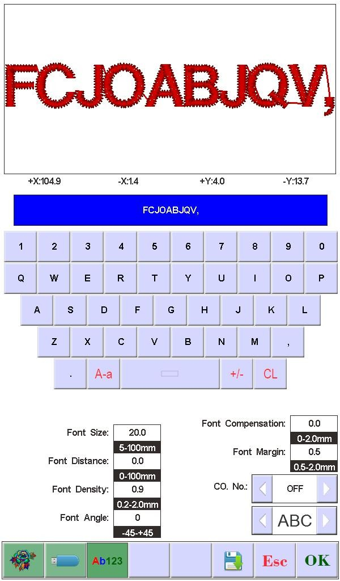
In the flower management interface, press 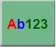 key to enter into letter interface. Press key to select required letters or other signs. Press key to switchupper-case and lower-case letters. Press 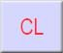 key to clear letter. After entering is completed. press key to skip to setting interface (operation cannot be continued if embroidery is not released).

Set letter related parameters. After setting is completed. press key below to select required letter type (5 types). Press key to generate letter pattern. On the left upper
corner. it can see the generated enbroidery card. Press key to save embroidery card

35

TE-510H COMPUTERIZED EMBROIDERY MANUAL V2.0

in memory.
The current letter string needs to use monochrome embroidery when the color order is closed, you need to open multi-color.

36

TE-510H COMPUTERIZED EMBROIDERY MANUAL V2.0

PART 7 MANUALLY CHANGE COLOR

In the working or preparation status. Click to switch manually change color
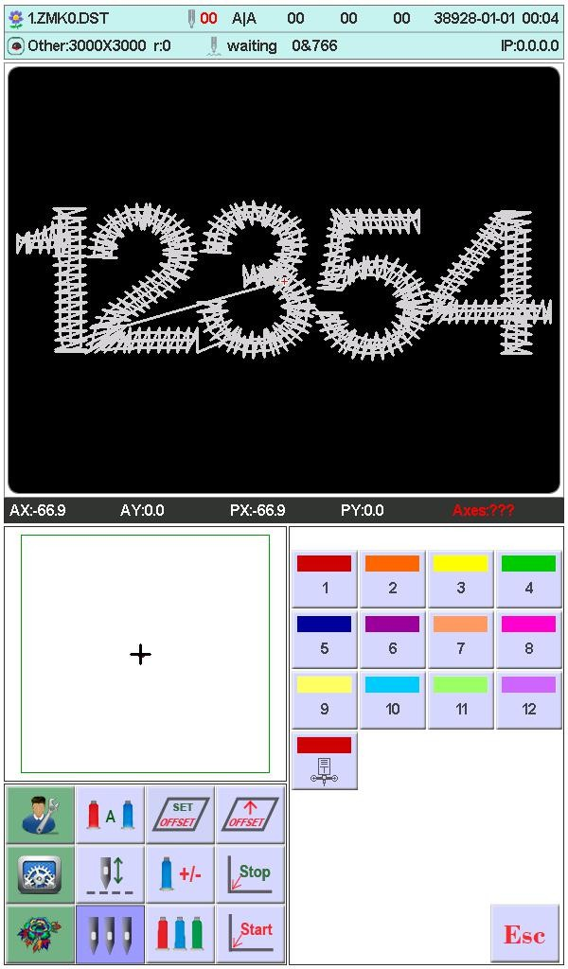
operation. it'll prompt that a numeric keypad. according to your requirements. click the corresponding numeric value to change color.

Press the number key to switch the ordinary head needle pole,Press Key switch to
tape embroidery Head (limited function).The Embroidery box will automatically switch to the current head position.

37

TE-510H COMPUTERIZED EMBROIDERY MANUAL V2.0

PART 8 MANUALLY TRIMMING

In the embroidery preparation or working status. can do the trimming operation. Click on the panel to do bottom side trimming operation.

38

TE-510H COMPUTERIZED EMBROIDERY MANUAL V2.0

PART 9 FRAME ORIGIN

Frame origin operation contains manually set origin. find absolute origin and set software limit.
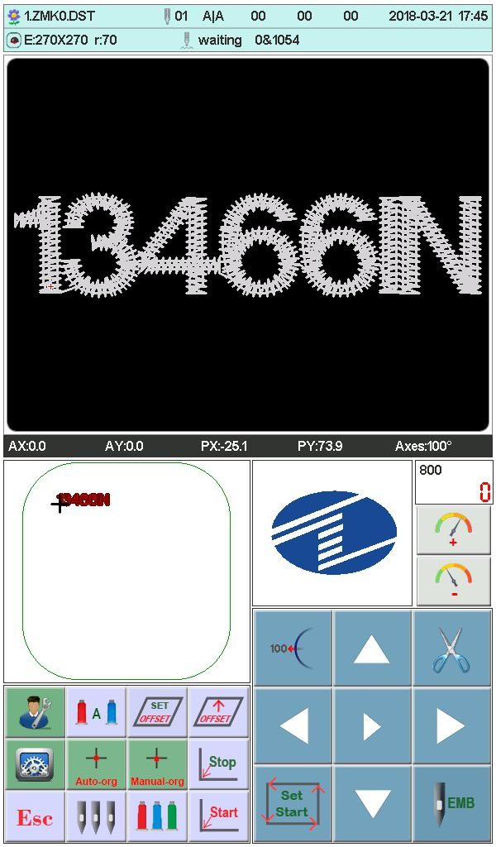
In the main interface, press key to enter the integrated setting interface，press 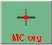 key to enter the original operation interface. show as:

Manually Set Frame Origin

In the "Frame Origin" interface. click . it'll prompt a dialogue box "Whether set the current point as frame origin?". click to complete. PX/PY coordinate change as

39

TE-510H COMPUTERIZED EMBROIDERY MANUAL V2.0

0.0.

Automatically Find Absolute Origin

Absolute origin take use of frame limit to detect frame's absolute position. to ensure that some accidents happen in the embroidery midway. can use recovery embroidery to continue.

The function is automatically find by system. must confirm that limit sensor is effect. or it'll cause machine parts destroy!
In the frame origin interface. click . it'll prompt a dialogue "Please confirm limit switch work normal?". click to find frame origin absolute origin. completed. return the prior stop point.
After finding the absolute origin. the operation will be not effect until the frame moves after power off.

40

TE-510H COMPUTERIZED EMBROIDERY MANUAL V2.0

PART 10 FRAME SET

The feature use to set the size of cap frame and A-E frame. and the distance between from frame absolute origin to frame middle.
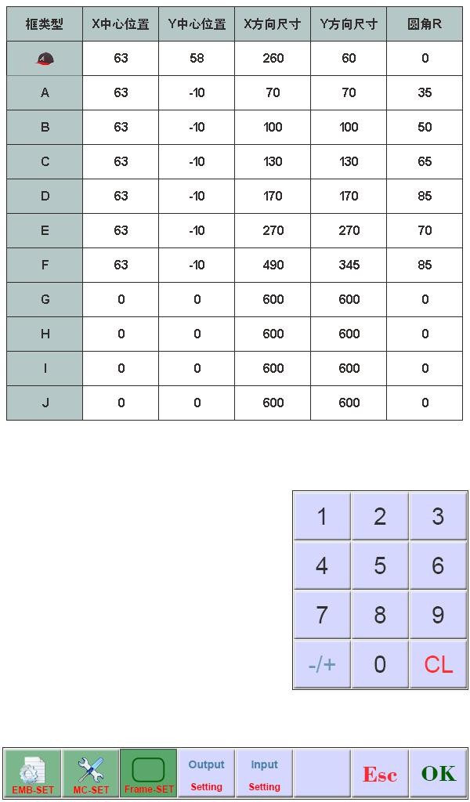
In the main interface, press key to enter the parameter setting interface. click . show as:

Input numeric value according to your requirements. then click to save.

41

TE-510H COMPUTERIZED EMBROIDERY MANUAL V2.0

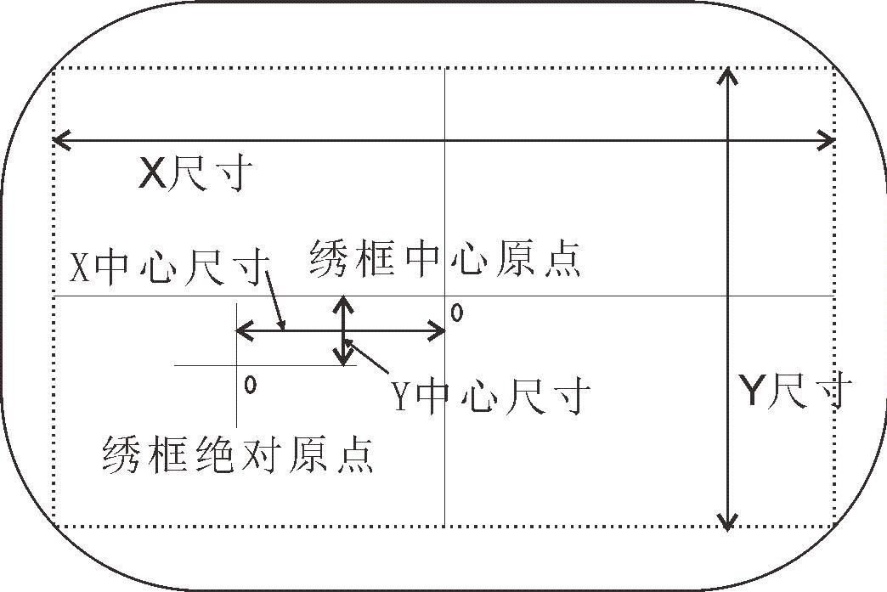
X S ize

X Center size Frame center
Y Center size Y S ize Space Origin

42

TE-510H COMPUTERIZED EMBROIDERY MANUAL V2.0

PART 11 STATISTIC

The feature use to view generated statistic and clear statistic.
In the main interface, press key to enter the integrated setting interface ，
click .

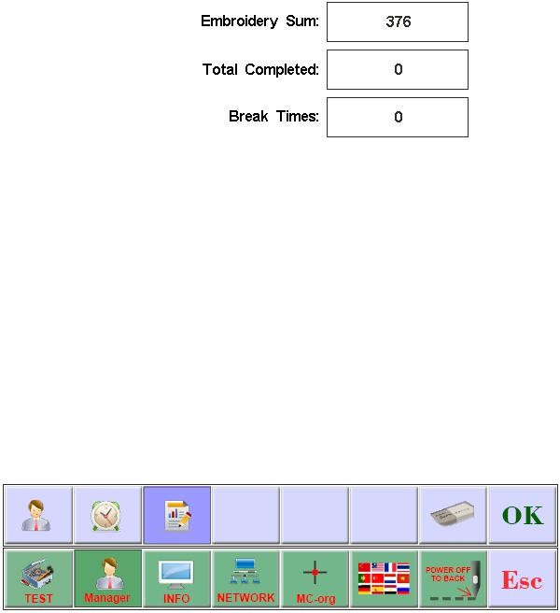

Click to clear the current statistic value.

43

TE-510H COMPUTERIZED EMBROIDERY MANUAL V2.0

PART 12 MAIN AXIS JOG OPERATION

The feature use that main axis position stop. can operate it in the interface matched with keys.
According to your requirements to do it.
Click to jog main axis to 100 degree (Zero positon)

44

TE-510H COMPUTERIZED EMBROIDERY MANUAL V2.0

PART 13 LANGUAGES

In the main interface, press key to enter the integrated setting interface，click to change required languages.Click to select the desired language, the system automatically switches to the selected language.

45

TE-510H COMPUTERIZED EMBROIDERY MANUAL V2.0

PART 14 EMBROIDERY PARAMETERS

Owing to different machine configuration and embroidery process requirements. need to change some commonly used parameters to meet.
In the main menu. click . click the required parameter. click or to modify. click to save. then return the main menu.
The definition and the value range of embroidery parameter. see Table 1.

46

TE-510H COMPUTERIZED EMBROIDERY MANUAL V2.0

PART 15 SET MACHINE PARAMETERS

The parameters only can be set by professional engineers. the other can not. please don't freely change and modify. to avoid machine can not work.

47

TE-510H COMPUTERIZED EMBROIDERY MANUAL V2.0

PART 16 USERS MANAGEMENT

In the main interface, press key to enter the integrated setting interface， Press the key to enter the user management interface. In this interface, you can set the time setting and user limit. Figure:

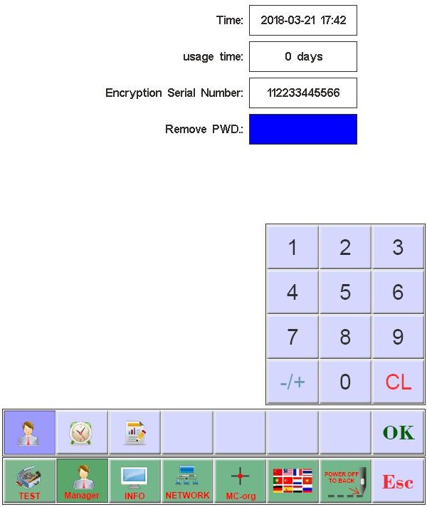

16.1 Time setting

Press the key to enter the time setting interface (if the device is open after the restrictions can not enter the time setting interface), as shown in Figure:

48

TE-510H COMPUTERIZED EMBROIDERY MANUAL V2.0

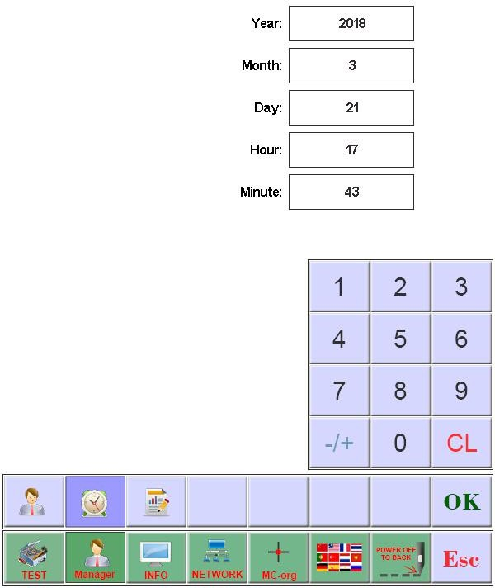

Set the current system time as needed, press the key to save.

16.1 Remove Unlock

The machine because of restrictions on the use of expiration, the system automatically lock the machine, and prompted to enter the release limit password. Figure:

49

TE-510H COMPUTERIZED EMBROIDERY MANUAL V2.0

After the encrypted serial number is told to the device vendor, the user can obtain the
unlocked password and press the key to complete the unlocking of the current limit. After the release of the use of time will be re-set, 0 days for the use of restrictions.
Do not close the current device until the password is removed. Otherwise, the password will not be released.

50

TE-510H COMPUTERIZED EMBROIDERY MANUAL V2.0

PART 17 SYSTEM TEST

The operation mainly be used by maintenance engineer. check and test machine. In the main interface, press key to enter the integrated setting interface.

Input Test

In the test interface. click 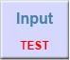 . view the input status changes. if no change. the input signal fault. please check and repair.

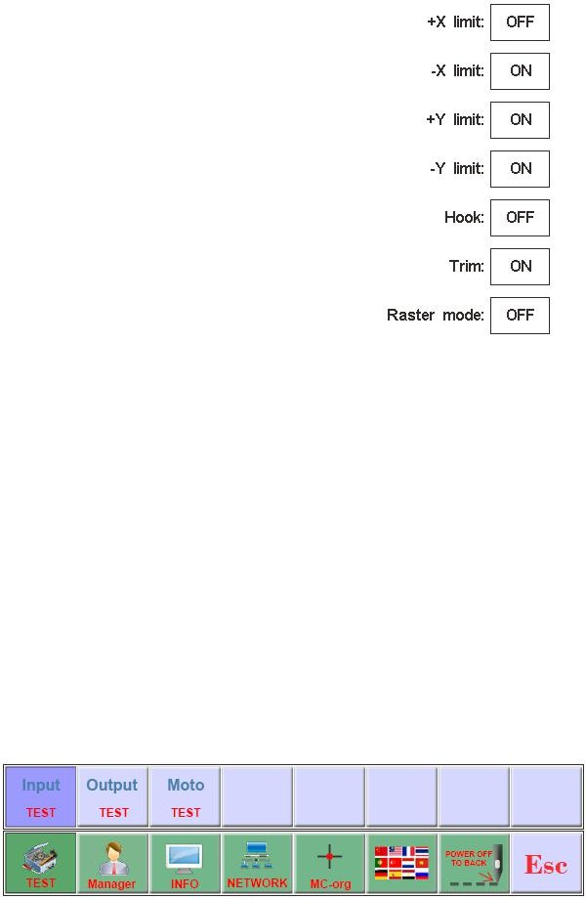

Output Test

In the test interface. click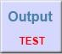.

51

TE-510H COMPUTERIZED EMBROIDERY MANUAL V2.0

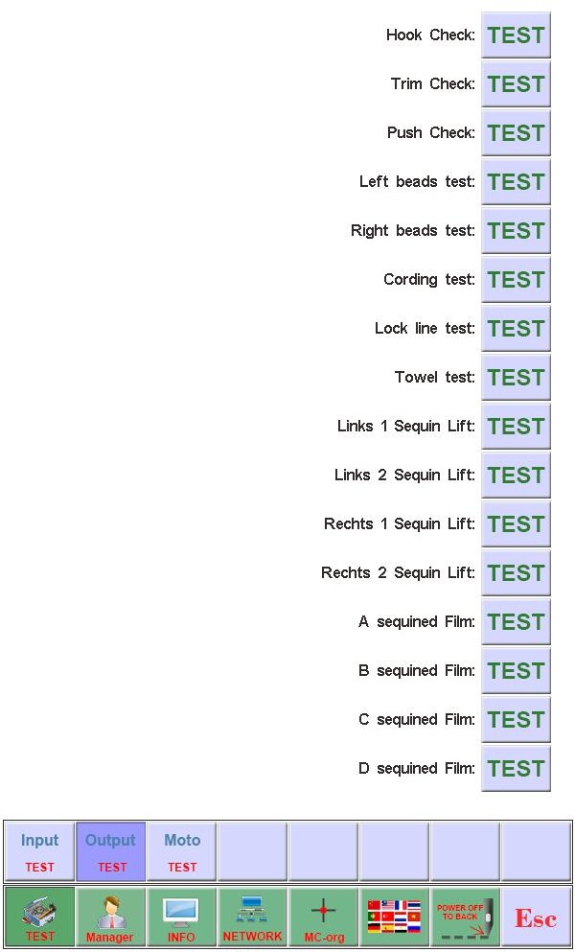

click the corresponding key of required testing items. check whether output has effect or not. if the output device no action. the output is fault. please check and repair.
Hook Test: each click. hook knife will do the alternating movement between stretch and reverse.
Trim Test: each click. trim motor will do the alternating movement that turn a half of circle and stop. and one-half turn in the same direction in place.
Buckle Test: each click. buckle electromagnets pull 2 seconds to automatically disconnect.
Sequin Test: each click. sequin landing gear perform decline. slice 3 times. rising.

Axis Test

In the "Test" interface. click 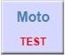 into "Axis Test". and click the corresponding key of required testing items. check whether axis has effect or not. if the output

52

TE-510H COMPUTERIZED EMBROIDERY MANUAL V2.0

device no action. the output is fault. please check and repair.
XY axis Test: click direction keys to change motor moving pulse numbers(1-127). the
default is 127 pulses. click to begin to move back and forth.
Main Axis Test: click to begin to turn by 100 rev/min. click direction keys to modify main axis speed. Check target speed and actual speed are the same(1000rpm
difference of less than 5rpm)

Machine Head Test (Used only in organic head panels)

In the test interface, pres key to enter into machine head breakage test. Press figure button to test corresponding needle bar. Check whether breakage detection is valid. If
the pre-out has fault, Please check and make maintenance.
Facial suture test: When facial suture test spring is closed, red indicator is normally on. It is changed into green when it is separated.
Bottom suture test: Toggle the test wheel. The indicator is flashing along with the toggle speed. Select facial suture and bottom suture according to the requirements.

PART 18 SYSTEM INFORMATION

In the main interface, press key to enter the integrated setting interface, In the main menu. click .

System No. and Version Info

In the system info interface. click 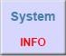 to view.

53

TE-510H COMPUTERIZED EMBROIDERY MANUAL V2.0

System Update

Used to update new software.
In the system info interface. click 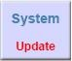 to update. Follow the prompts to upgrade,
Follow the prompts to upgrade, in the upgrade process can not power. About 3 minutes to complete the upgrade, the system automatically restart. You can not unplug the U disk before restarting.

Interface upgrade

The library file used to upgrade the control system.
In the system information interface, press the 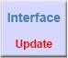 key to start the upgrade
operation. Follow the prompts to upgrade, in the upgrade process can not power. About 8 minutes to complete the upgrade, the system automatically restart. You can not unplug the U disk before restarting.

54

TE-510H COMPUTERIZED EMBROIDERY MANUAL V2.0

PART 19 Network settings

In the main interface, press key to enter the integrated setting interface,
In the main menu interface, press the key to enter the network settings interface.
Depending on the system configuration, you need to set up the system IP when using a wired connection. Use the wireless connection need to search WIFI to connect, the specific operation is as follows.
IP settings:
the machine must set the IP and LAN IP in the same number, or can not link. That is, the first three segments of the same, the final address does not conflict.
WIFI connection:
enter the search interface to search for a nearby wireless connection account, the system automatically sorted by the signal strength, select the need to connect the account (account name is limited to az / AZ and digital, other characters can not be displayed correctly), enter the password input interface , Enter the password (password is limited to az / AZ and digital,
other characters can not enter), press the button to connect, after the success of the main interface shows the IP address, the connection is not successful when the error message.

55

TE-510H COMPUTERIZED EMBROIDERY MANUAL V2.0

PART 20 APPENDIX

20. 1 Parameter Table

Name | Functions | Default | Range
A
Jump stitch trim  number | It starts to trim or not when several stitch  jumped | 3 | 1-9, no trim
Width thread trim length | The remaining thread length after  trimmed, a higher number means a longer remaining | 3 | 1-7
Bottom thread  break detect | Check sensitivity | Middle | High, middle,  low, no detection
Width thread  break detect | Check sensitivity | 5 stitches | 3-9 stitches, no  detection
Jump stitch  break detect | Detect breaking whether or not when  jumping | No | Yes, No
Upper thread  lock angles | Close the open angle again after startup. | 200 | 200-250
Trim lock times | Lock several stitches when trimming, to  avoid off-thread | 1 | 1-3
Trim lock stitch length | Increase lock stitch length if the material  is thin, and decrease lock stitch length properly if it's thick | 0.6mm | 0.5-1.0mm
Break  auto-return | Auto-return stitches after breaking, the  break head will compensate embroidery ahead | 4 | 0-9
Auto-set start  point | Set "Yes" when designs in the head and  tail continuous embroidery | Yes | Yes, No

56

TE-510H COMPUTERIZED EMBROIDERY MANUAL V2.0

B
Auto-return start  point | Whether or not to return start point after embroidery, set "No" in the end-to-end  continuous embroidery | Yes | Yes, No
Pull stitches continuous back | Return stitches automatically and  continuously after several stitches when pull stitches | 0 | 0-9
Large stitch  embroidery mode | Which modes to use when large stitch | Low speed | Low speed, jump
Auto-jump  stitches | When large stitch is in auto-jump, divided  into 2 stitches or more automatically if stitches is over a certain range | 6.5mm | 6.5-8.5mm
Auto-decelerate  stitches | Decelerate embroidery speed if stitches is  over a certain range | 6.0mm | 2.0-9.0mm
Continuously jump  deceleration | When jump continuously, decelerate to a percentage of the current speed | 80％ | 60％-90％
Start main axis rotation speed | Main axis rotation speed when starting or  stopping, it will increase the trim length when the rotational speed rises | 100 | 60-200
Max. restrict  speed | Main axis maximum rotation speed ( by  machine parameter limit) | 750 | 550-1000
High-speed moving frame  speed | Set high-speed moving speed,  a higher number means a higher speed | 5 | 1-9
Stepper change  color speed | The changeable color speed when use  stepper motor | 5 | 0-9
C
Auto-start same  color | Whether or not to auto-start when meet the same color stitch bar | Yes | Yes, No

57

TE-510H COMPUTERIZED EMBROIDERY MANUAL V2.0

pull stitch beyond frame and stop | Whether or not to stop when pull stitch beyond frame | Yes | Yes, No
Machine stitch  bar quantity | The current machine used stitch bar  quantities | n* | 1-15
Sequin stitch bar | Use left, right or both of them. The parameter is invalid if the feature closed  in the machine | left* | left、right、left and  right
Sequin embroidery limit  speed | Main axis max. rotation speed at the sequin embroidery | 700 | 300-1000
Carve knife  stitch position | Use the position of carve knife (no  breaking detection) | 0 | 0-n
Rope  embroidery stitch position | Use rope embroidery stitch position (auto-deceleration) | 0 | 0-n
Rope  embroidery limit speed | Main axis max. rotation speed at the rope embroidery | 300 | 300-800
Circle  embroidery | Whether or not to continue to embroidery | No | Yes, No
Auto Back Offset | Whether or not the frame automatically shift to stop to its top after the completion of the embroidery (the frame parameter  must be correspondent to its size) | No | Yes, No
D
Frame moving  curve | Frame moving mode, adjustment  according to the actual embroidery effect | F1* | F1-F5
Frame moving  angle | Frame moving angle, adjustment according to the actual embroidery effect | 250* | 220-270

58

TE-510H COMPUTERIZED EMBROIDERY MANUAL V2.0

Moving frame compensation  time | Thin material use positive compensation, thick material use negative compensation, adjustment according to the actual embroidery effect | 0 | 5 ％ , 0, -5%,  -10%
Whether or not  to use trimming | Whether or not to use trimming | Yes | Yes, No
Break rise  landing gear | Whether or not to rise landing gear after breaking in the sequin | Yes | Yes, No
Reset frame  after power on | Whether or not find frame absolute origin  after power on | No | Yes, No
Landing gear  type | Sequin landing gear mode | motor | Motor, pneumatic
Left sequin size | Left sequin slice size | 3* | 3-9
Right sequin  size | Right sequin slice size | 3* | 3-9
Various speed  stitch numeric | Adjust speed less than continuous stitches | 20* | 5-20
E
Main axis brake  delay | The larger the numeric is, the later the brake angle is | 8* | 1-20
Whether or not to move frame  after trimming | Whether or not to move frame after trimming | No | Yes, No
Hook motor  speed | Adjust hook stepper motor speed | 5* | 1-5
Sequin lift speed | Adjust lift stepper motor speed | 3* | 1-4
Broken voice  prompts | How long to prompt once after a break  for each time interval | 1 | 1-3, Close
Cording shelf  type | Which kind of frame of rope embroidery  to use | JY* | JY, GJ

59

TE-510H COMPUTERIZED EMBROIDERY MANUAL V2.0

Cording lifting  methods | A lift mode for rope embroidery | Power* | Power, Air valve
Cording swing  amplitude | Adjustment of swing for rope embroidery | 20 | 0-20
Cording slack  adjuster | Loose or tight adjustment for  rope embroidery | 1* | 0-9
Cording lifting  speed | Lifting speed of rope embroidery | 3* | 1-4

n* machine use stitches (no default)
-* set according to your requirements (no default)

20. 2 System Fault and Solution

Fault | Cause | Solution
ation timeout or 1/2 communication timeout of Multifunction  board | 1.A signal line connection fault from operation head to Multifunction board 2.Multifunction board is not match with operation head  3.Multifunction board destroy | 1.Overhaul the Cable 2.Replace Multifunction board 3.Replace Multifunction board
Touch Panel has no response | 1.Poor contact of touch panel’s plug 2.Touch panel destroy | 1. Re-insert touch panel’s plug 2.Replace touch panel
The movement of touch panel（the malposition of  Touch position） | 1.Ageing touch panel 2.Touch panel destroy | - Recalibrate the touch panel’s position  - Replace touch panel
Main axis not in the 100 degree | Main axis don't stop 100 degree | Jog or manually move main axis to 100 degree
Main axis not turn | - Main axis controller no signal or power input  - Main axis motor no power input or input fault  - Controller or motor destroy | 1.check signal wire or power wire 2.check main axis motor input power 3.replace controller or motor
Main axis reverse | 1.Servo controller parameter error | 1.Reset servo controller parameter

60

TE-510H COMPUTERIZED EMBROIDERY MANUAL V2.0

turn | 2.Coder A/B phase reversed | 2.Adjust coder A/B phase connection
No zero position | - Zero signal panel destroy  - Zero position to main board connection fault | 1.Replace zero position panel 2.Check or replace connection wire
Change color overtime | 1.Change color motor not turn 2.Machine part of change color stuck  3.Change color motor to power wire fault | 1.Check change color motor or wire 2.Repair or replace the stuck machine part 3.Check or replace wire
No stitch position | - Stitch detection wheel position fault  - Stitch detection board destroy | - Adjust the position  - Replace the board
X motor driver fault | - X driver over-voltage or over-current protection  - Driver destroy | - Check driver input power and power on again  - Replace driver
Y motor driver fault | - Y driver over-voltage or over-current protection  - Driver destroy | - Check driver input power and power on again  - Replace driver
Trim not in place | 1.Proximity switch detection not in place 2.Proximity switch destroy | 1.Manually adjust trim position 2.Replace proximity switch
Trim motor does not turn | 1.Poor contact of motor plug or cable 2.Multifunction board destroy 3.Motor destroy | 1.Check cable or plug, re-insert plug 2.replace multifunction board 3.Replace motor
Hook motor does not turn | 1.Poor contact of motor plug or cable 2.Multifunction board destroy 3.Motor destroy | 1.Check cable or plug, re-insert plug 2.Replace multifunction board 3.Replace motor
Lock head fault(stitch rod drop) | 1.Poor contact of motor plug or cable 2.Multifunction board destroy 3.Motor destroy  4.Mechanical malposition or stuck | 1.Check cable or plug, re-insert plug 2.Replace multifunction board 3.Replace motor  4.Maintenance of machinery part
Sequin position  fault | Sequin stitch bar set fault | Reset change color sequence
Abnormal detection for stitch break | - Optical coupler installation position is not correct  - Optical coupler board destroy  - Cable or plug fault from optical coupler to multifunction board  - Multifunction board destroy 5.Embroidery parameter “Width thread break detect ”or “Bottom thread break  detect” setting error | 1.Re-adjustment of installation 2.Replace optical coupler 3.Check cable, re-insert plug 4.Replace multifunction board  5.Adjust Embroidery parameter correctly

61

TE-510H COMPUTERIZED EMBROIDERY MANUAL V2.0

Design malposition | 1.Design data error 2.High rotating speed 3.Low XY driver current 4.Mechanical failure | - Check design  - Reduce main axis rotating speed  - Adjust the drive current or change the speed of the needle-step numerical values
 |  | 4.Maintenance of machinery part
+X limit fault | +X direction limit | Manually move frame in opposite direction
-X limit fault | -X direction limit | Manually move frame in opposite direction
+Y limit fault | +Y direction limit | Manually move frame in opposite direction
-Y limit fault | -Y direction limit | Manually move frame in opposite direction

62

